Notes regarding’ the problems and solutions of listening and speaking of English’ have been uploaded if you have any suggestion or find any error in it please inform us. It will be rectified as soon as possible.
Bawa 95010-34232
Full disclaimer from all points of view.
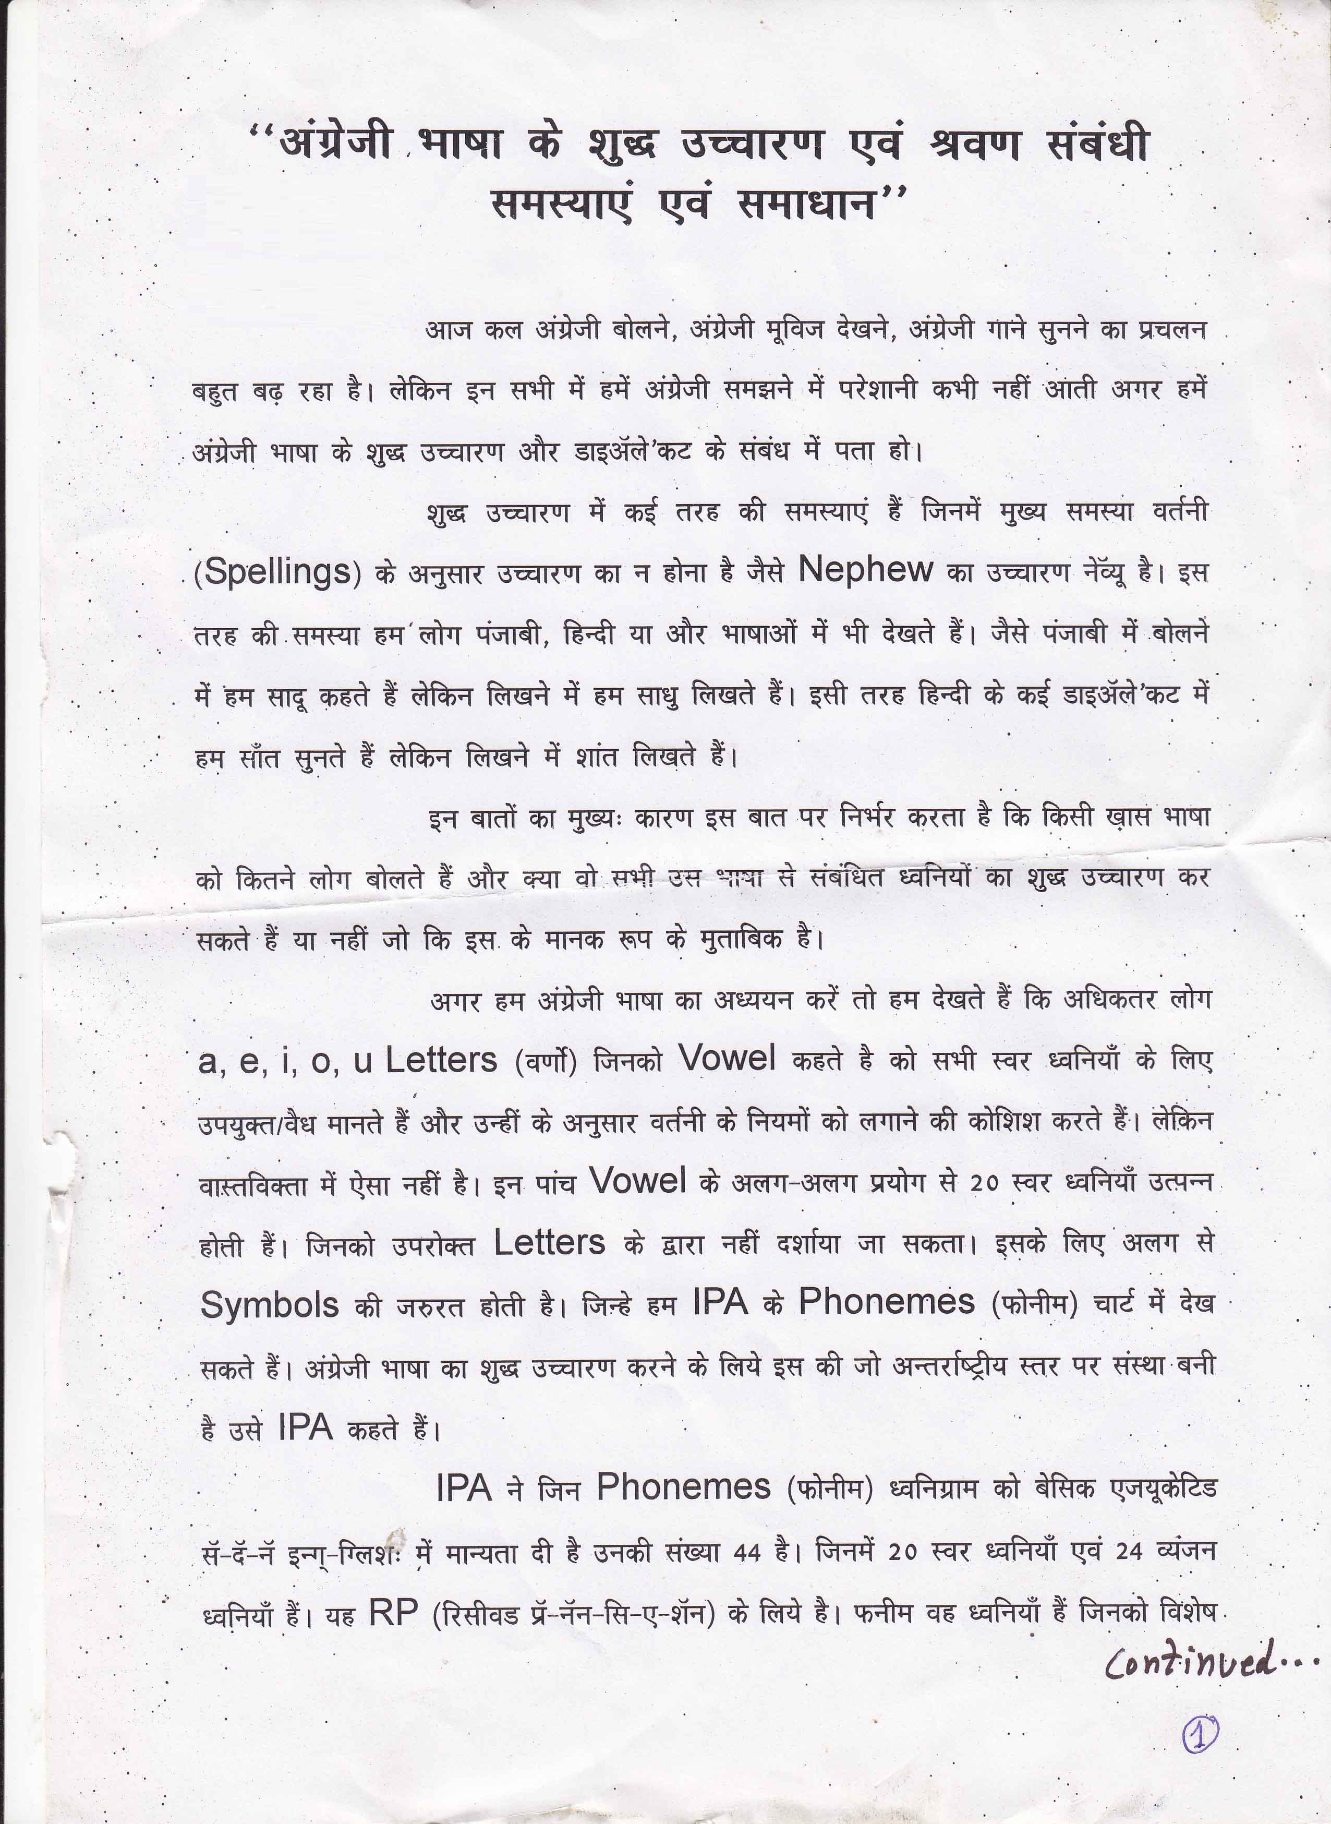
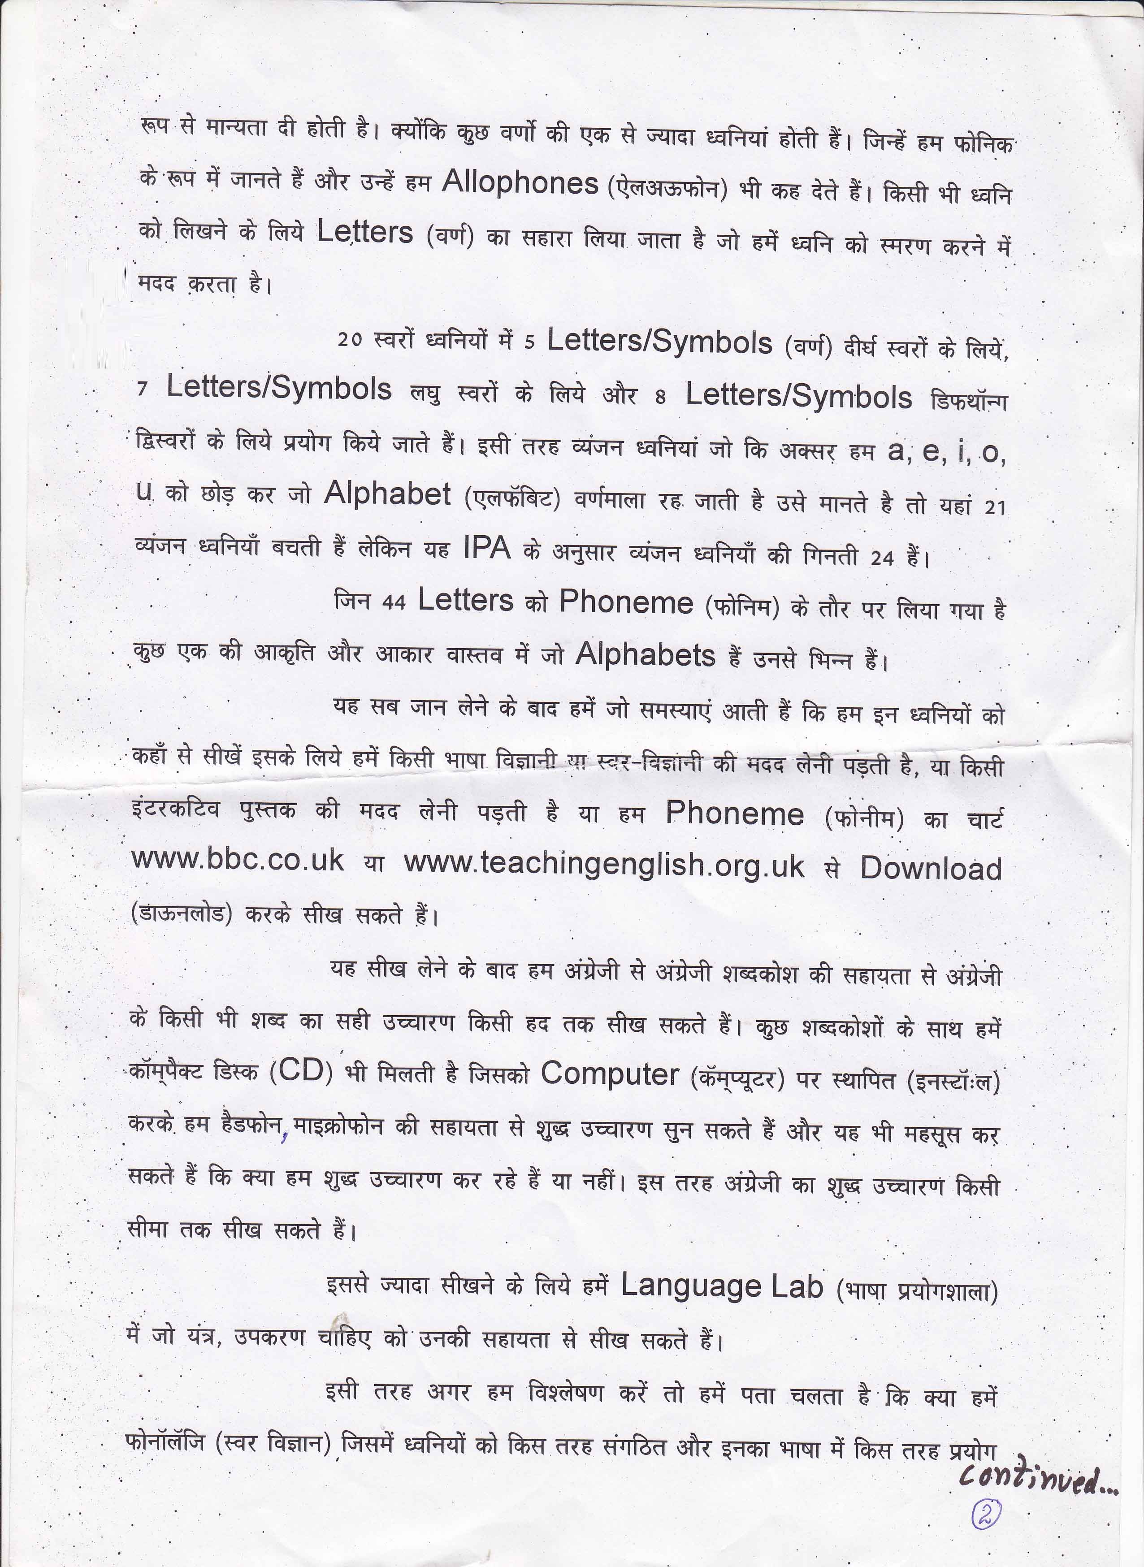
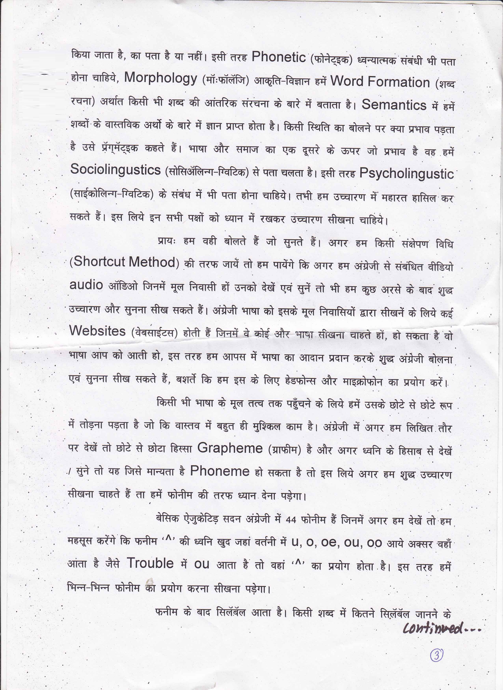
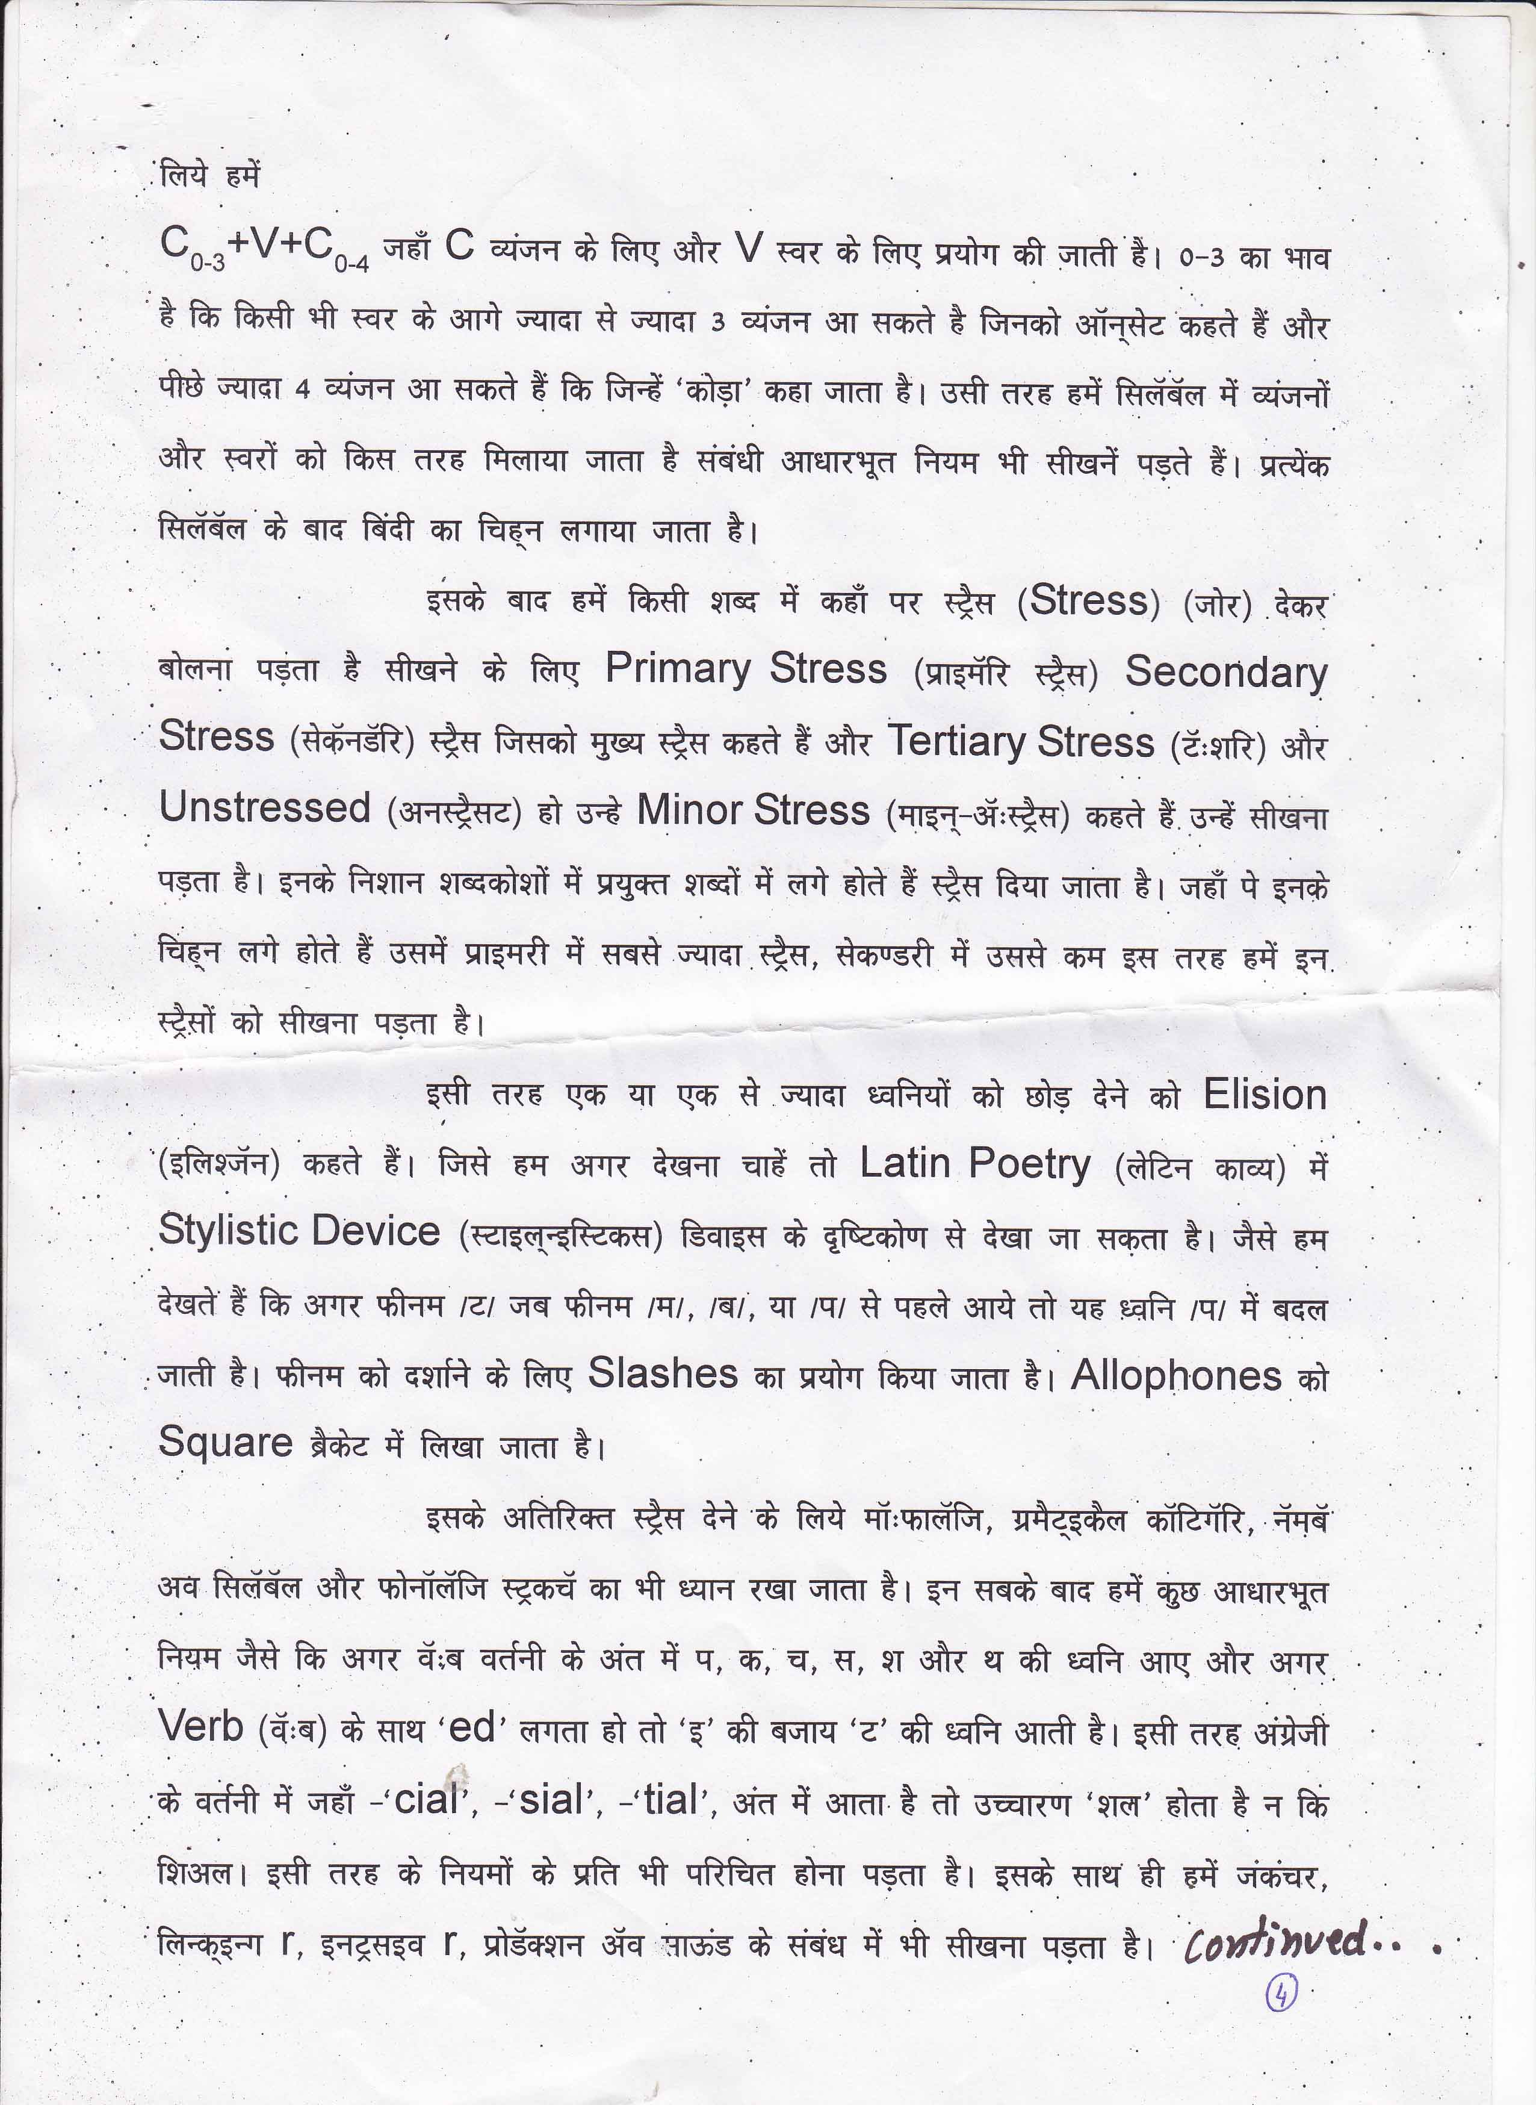
Full disclaimer from all points of view.

